**Instituto Politécnico Nacional**

**Escuela Superior de Cómputo**

*Fundamental Analysis of Circuits*

Practice 4: Oscilloscope Management.

Group: 1CV13

Team: 7

Members:

Pastor Martínez Luis Enrique

Partido Terrón Luis Alberto

Pérez Garduño José Emiliano

Professor:

Raúl Santillán Luna

Practice day: October 2, 2017

Delivery day: October 16, 2017

**Index:**

1. Objective
2. Introduction
3. Development
4. Calculations
5. Conclusions

**Objective:**

At the end of the practice the student will be capacitated for:

* The management of the controls in the oscilloscope.
* Evaluating the signal setting for test cables of an oscilloscope of general use.
* Operate a voltage signal generator in sinusoidal functions, square and triangular.
* Measure voltage from direct current utilizing the horizontal entrance and vertical entrance of the oscilloscope.
* Obtain and evaluate graphics of voltage vs time in basic circuits to measure amplitudes, periods and frequency of voltage signals.
* Utilizing both entrances of the oscilloscope for the measurement of the desynchronies between two sinusoidal signals through the Y(t) mode and the figures of Lissajous in the XY mode.

**Introduction:**

***Oscilloscope:*** An oscilloscope, CRO (for cathode-ray oscilloscope), or DSO (for the more modern digital storage oscilloscope), is a type of electronic test instrument that allows observation of constantly varying signal voltages, usually as a two-dimensional plot of one or more signals as a function of time. Other signals (such as sound or vibration) can be converted to voltages and displayed.

Oscilloscopes are used to observe the change of an electrical signal over time, such that voltage and time describe a shape which is continuously graphed against a calibrated scale. The observed waveform can be analyzed for such properties as amplitude, frequency, rise time, time interval, distortion and others. Modern digital instruments may calculate and display these properties directly.

Originally, calculation of these values required manually measuring the waveform against the scales built into the screen of the instrument. The oscilloscope can be adjusted so that repetitive signals can be observed as a continuous shape on the screen. A storage oscilloscope allows single events to be captured by the instrument and displayed for a relatively long time, allowing observation of events too fast to be directly perceptible.

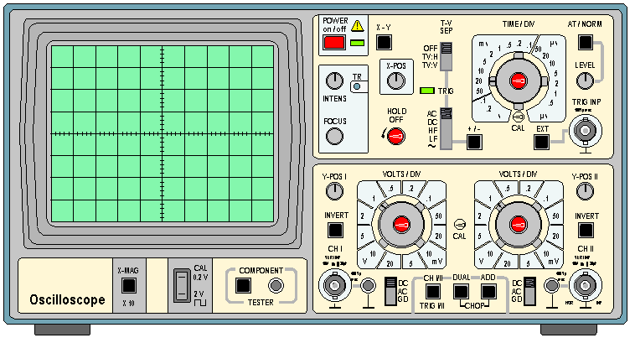

The basic oscilloscope is typically divided into four sections: the display, vertical controls, horizontal controls and trigger controls. The display is usually a CRT or LCD panel which is laid out with both horizontal and vertical reference lines referred to as the graticule. In addition to the screen, most display sections are equipped with three basic controls: a focus knob, an intensity knob and a beam finder button.

Many scopes have measurement tools, which help to quickly quantify frequency, amplitude, and other waveform characteristics. In general a scope can measure both time-based and voltage-based characteristics:

Timing characteristics:

* Frequency and period – Frequency is defined as the number of times per second a waveform repeats. And the period is the reciprocal of that (number of seconds each repeating waveform takes). The maximum frequency a scope can measure varies, but it’s often in the 100’s of MHz (1E6 Hz) range.
* Duty cycle – The percentage of a period that a wave is either positive or negative (there are both positive and negative duty cycles). The duty cycle is a ratio that tells you how long a signal is “on” versus how long it’s “off” each period.
* Rise and fall time – Signals can’t instantaneously go from 0V to 5V, they have to smoothly rise. The duration of a wave going from a low point to a high point is called the rise time, and fall time measures the opposite. These characteristics are important when considering how fast a circuit can respond to signals.

Voltage characteristics:

* Amplitude – Amplitude is a measure of the magnitude of a signal. There are a variety of amplitude measurements including peak-to-peak amplitude, which measures the absolute difference between a high and low voltage point of a signal. Peak amplitude, on the other hand, only measures how high or low a signal is past 0V.
* Maximum and minimum voltages – The scope can tell the user exactly how high and low the voltage of your signal gets.
* Mean and average voltages – Oscilloscopes can calculate the average or mean of the signal, and it can also tell you the average of the signal’s minimum and maximum voltage.

Display:

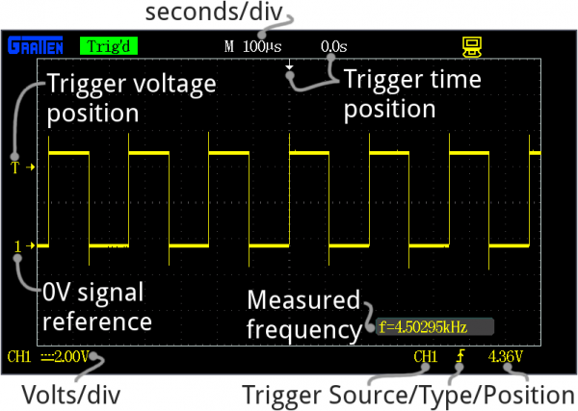

Every oscilloscope display should be crisscrossed with horizontal and vertical lines called divisions. The scale of those divisions are modified with the horizontal and vertical systems. The vertical system is measured in “volts per division” and the horizontal is “seconds per division”. Generally, scopes will feature around 8-10 vertical (voltage) divisions, and 10-14 horizontal (seconds) divisions.

The vertical section of the scope controls the voltage scale on the display. There are traditionally two knobs in this section, which allow you to individually control the vertical position and volts/div.

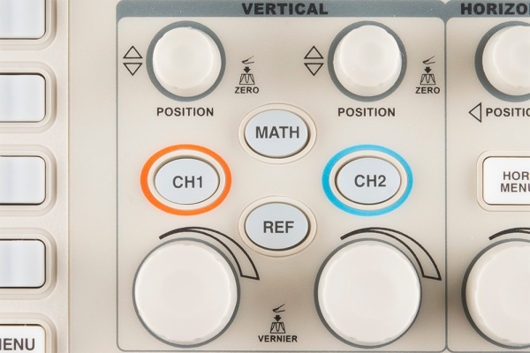

The more critical volts per division knob allows you to set the vertical scale on the screen. Rotating the knob clockwise will decrease the scale, and counter-clockwise will increase. A smaller scale – fewer volts per division on the screen – means you’re more “zoomed in” to the waveform.

The position knob controls the vertical offset of the waveform on the screen. Rotate the knob clockwise, and the wave will move down, counter-clockwise will move it up the display. You can use the position knob to offset part of a waveform off the screen.

The horizontal section of the scope controls the time scale on the screen. Like the vertical system, the horizontal control gives you two knobs: position and seconds/div.

The position knob can move your waveform to the right or left of the display, adjusting the horizontal offset.

Trigger:

The trigger section is devoted to stabilizing and focusing the oscilloscope. The trigger tells the scope what parts of the signal to “trigger” on and start measuring. If your waveform is periodic, the trigger can be manipulated to keep the display static and unflinching.

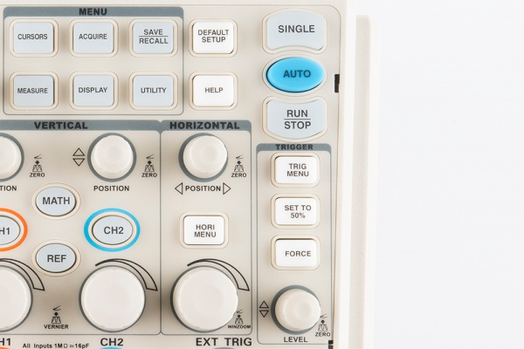

A series of buttons and screen menus make up the rest of the trigger system. Their main purpose is to select the trigger source and mode. There are a variety of trigger types, which manipulate how the trigger is activated:

* An edge trigger is the most basic form of the trigger. It will key the oscilloscope to start measuring when the signal voltage passes a certain level. An edge trigger can be set to catch on a rising or falling edge (or both).
* A pulse trigger tells the scope to key in on a specified “pulse” of voltage. You can specify the duration and direction of the pulse. For example, it can be a tiny blip of 0V -> 5V -> 0V, or it can be a seconds-long dip from 5V to 0V, back to 5V.
* A slope trigger can be set to trigger the scope on a positive or negative slope over a specified amount of time.

***Function Generator:***

Function generators are items of test equipment that are able to generate a variety of simple repetitive waveforms. Straightforward signal generators such as RF signal generators or simple audio oscillators focus on producing a good sine waves, but in many cases other waveforms are needed. In addition to producing sine waves, function generators may typically produce other repetitive waveforms including saw tooth and triangular waveforms, square waves, and pulses. Another feature included on many function generators is the ability to add a DC offset. Often some of the low-end function generators may only operate up to frequencies of possibly around 100 kHz as the various shaped waveforms are normally only needed at lower frequencies. However, many other more comprehensive function generators are able to operate at much higher frequencies, often up to 10 or 20 MHz’s

Capabilities of a Function Generator:

* Sine wave: A function generator will normally have the capability to produce a standard sine wave output. This is the standard waveform that oscillates between two levels with a standard sinusoidal shape.

Figure 3.5 sine wave

* Square wave: A square wave is normally relatively easy for a function generator to produce. It consists of a signal moving directly between high and low levels.

Figure 3.6 square wave

* Triangular wave: This form of signal produced by the function generator linearly moves between a high and low point.

Figure 3.7 triangular wave

* Saw tooth wave: This is a triangular waveform, but with the rise edge of the waveform faster or slower than the fall, making a form of shape similar to a saw tooth.

**Development:**

1. **Measurement of the setting signal in the calibration terminal of the oscilloscope.**

Energize the oscilloscope and localize in the display the CALIBRATION setting. Connect the terminal to channel 1 through the oscilloscope cable, then choose the shoot supply (must be CH1). Adjust the controls of voltage amplitude (volts/div) and base time (time/div) to a scale that allows us to properly visualize a complete cycle of the calibration setting signal. Draw in the graticule shown below the resulting signal and report the characteristics in the signal that´s obtained, as in amplitude and frequency.

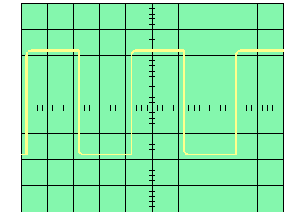

Channel 1

Time/Div= 250µs /Div

Volts/Div= 2.0 Volts/Div

Channel 1

Time/Div= 250µs /Div

Volts/Div= 2.0 Volts/Div

The period is calculated in the next manner:

For channel 1:

For channel 2:

The value of the frequency is calculated in the next manner: F=1/T.

For channel 1:

For channel 2:

The value of the amplitude of voltage peak peak is calculated in the next form:

For channel 1:

For channel 2:

1. Energize the signals generator, connect it´s terminal of output to the entrance in channel 1 of the oscilloscope, for that, utilize the BNC-BNC cables. Adjust the signal frequency to 10KHz and the amplitude to 10Vpp. Select the different forms of wave that the function generator delivers and fill the next table like it´s asked.

|  |  |  |  |  |
| --- | --- | --- | --- | --- |
| Function | Amplitud Vpp (volts) | Period T (Sec) | Frequency F (Hz) | Form of the signal (draw) |
| Sinusoidal | 10 | 10 | 0.1 |  |
| Triangular | 10 | 6.25 | 0.16 | Image result for funcion triangular osciloscopio |
| Square | 10 | 6.25 | 0.16 | Image result for funcion cuadrada osciloscopio |

Select a triangular signal of 5 Vpp to a frequency of 10KHz. Connect it to the channel 1 entrance in the oscilloscope, select the position of coupler to GND and verify that the lice cross the center of the oscilloscope graticule. As next step, select the position of CD coupler of the instrument. Activate the voltage generator OFFSET, in the generator, and find the minimum values and maximum of OFFSET to draw the oscilogram obtained in the next graticules.

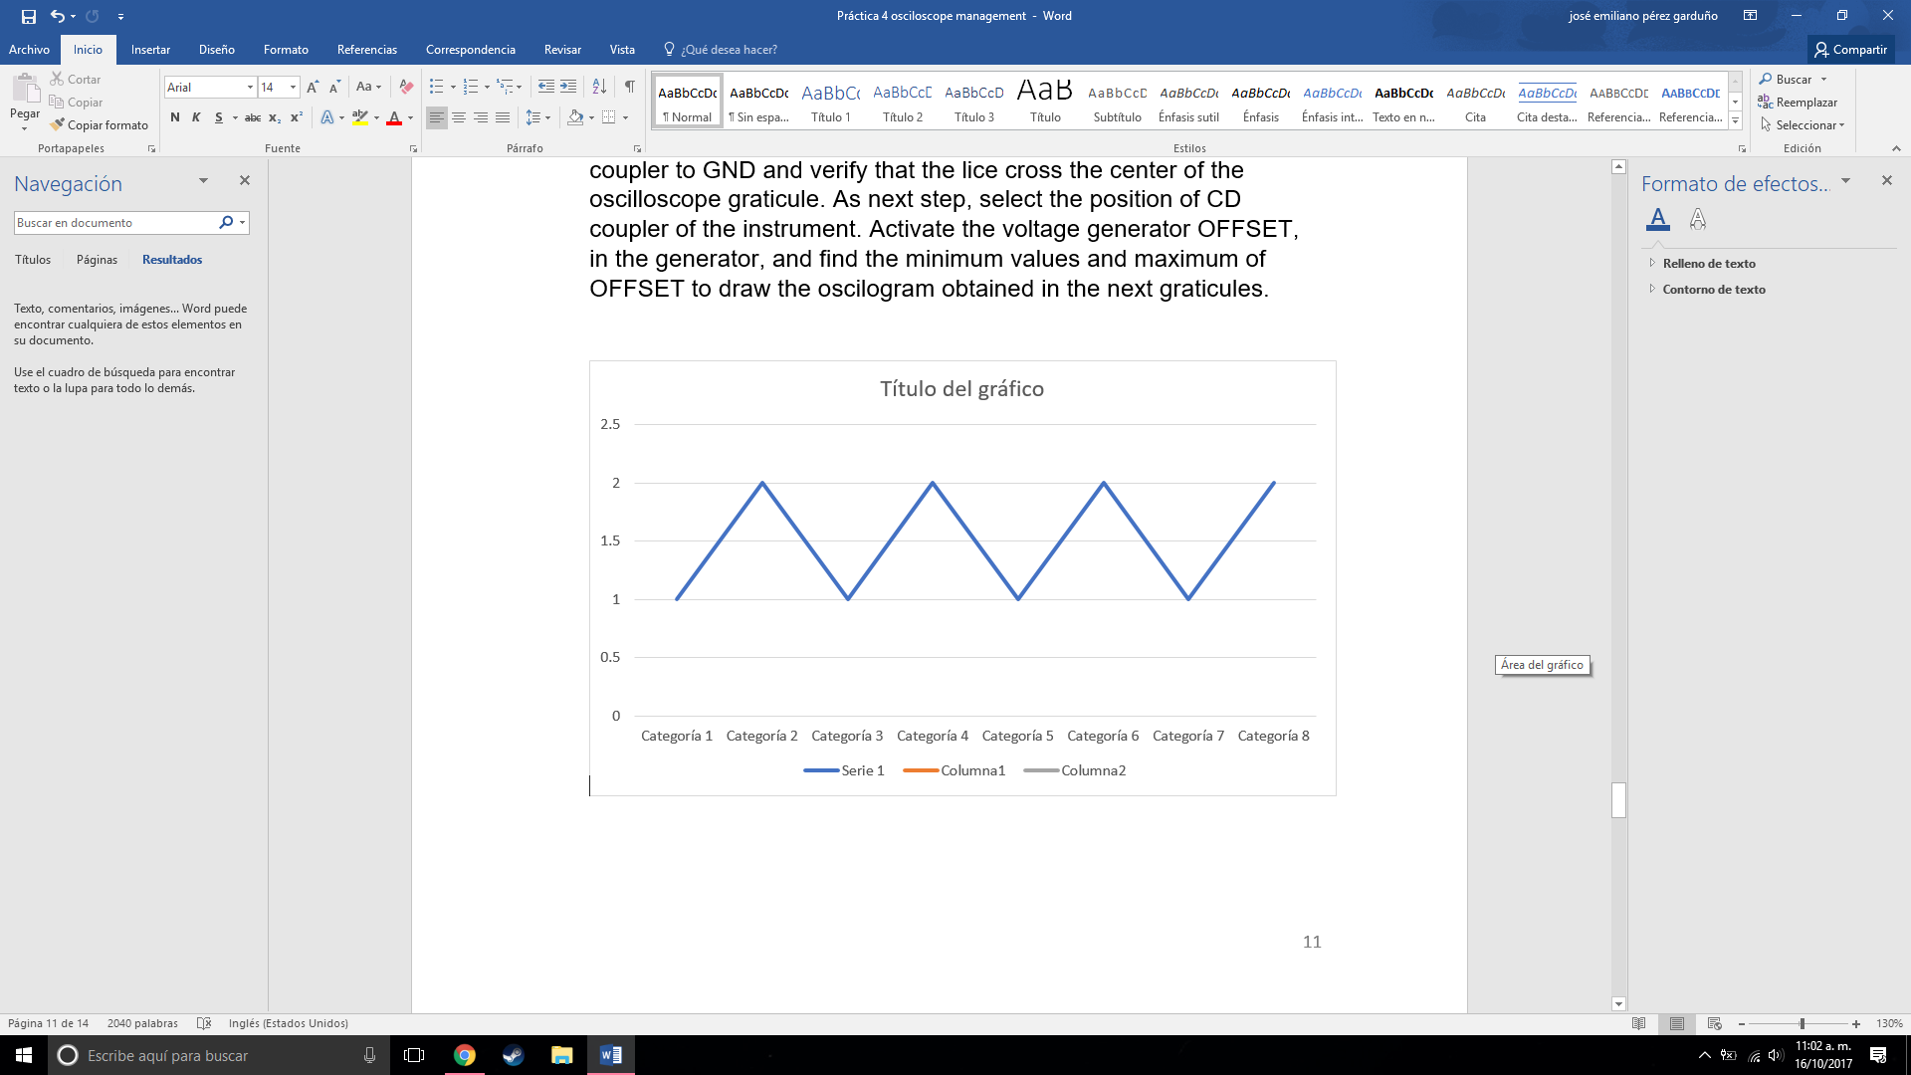 

MINIMUM VOLTAGE OF D.C. AGGGREGATED TO THE SIGNAL

OFFSETMIN= -7.5 volts

MAXIMUM VOLTAGE OF D.C. AGGGREGATED TO THE SIGNAL

OFFSETMAX= 7.5 volts

The Oscilloscope as X-Y graphic, with D.C. signals.

It will be measured in cartesian display the D.C. of entrance in the oscilloscope.

Put the oscilloscope in X-Y mode with the coupler section in GND. Control the position X and position Y controls to relocate the lines of both channels in the origin, with the center of the display of the oscilloscope.

Afterwards arm the circuit shown below with the oscilloscope cables connected to each point in every case. Realize the measurements indicated below, with the sectors of coupler in the channels X and Y of the oscilloscope with the D.C. position. Draw the resulting measurements collocating the number of each point.

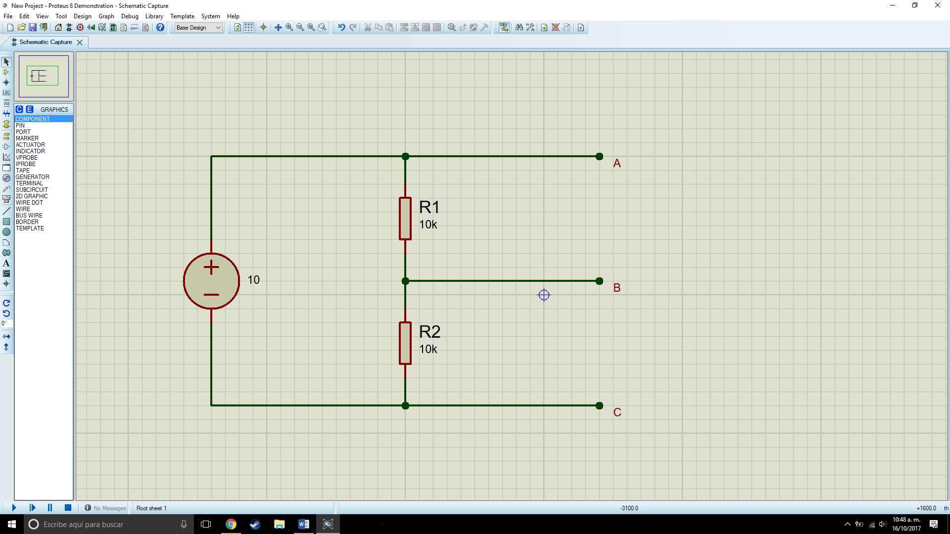

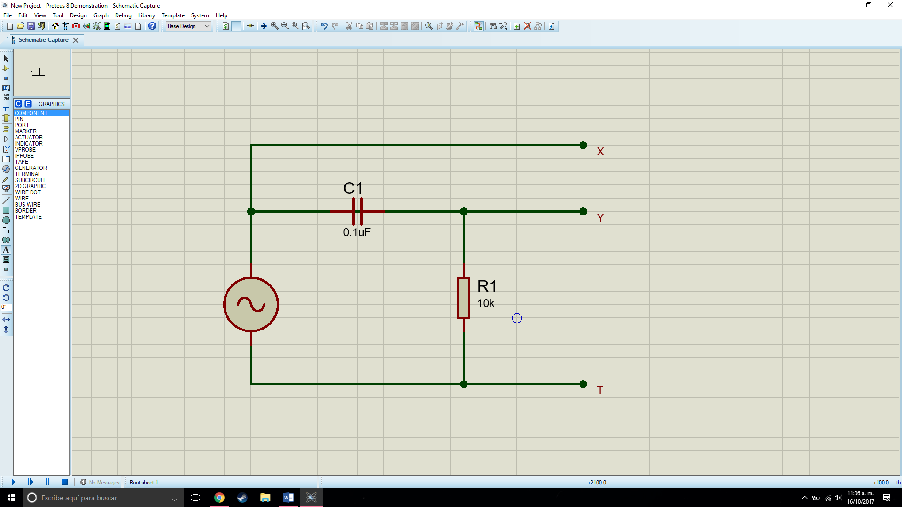

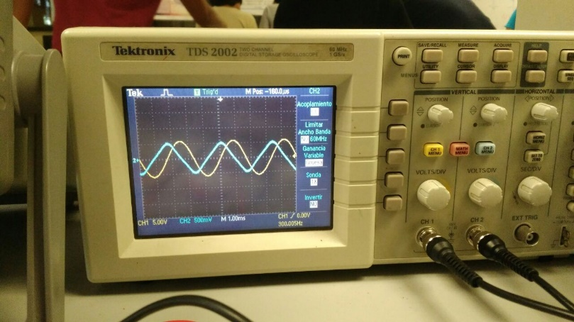

Y(t) mode:

Volts/Div= 5V

Time/Div = 1ms

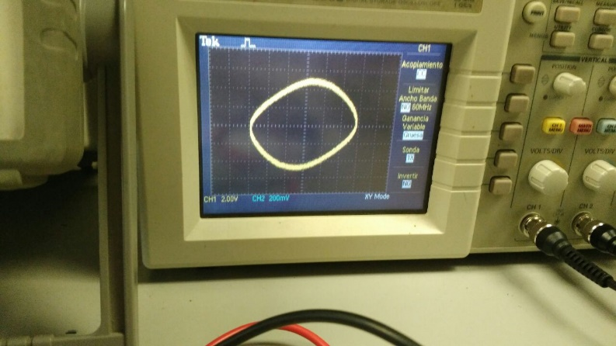

XY Mode

Volts/Div= 2.0

Time/Div= ---

**Conclusions:**

Luis Enrique: In this practice one learns to use instruments like the oscilloscope and the function generator to be able to make measurements in a circuit with alternating current.

Luis Alberto: This practice is important because it shows us how to use the oscilloscope for wave analyzing and more.

José Emiliano: The way we developed the practice was tiring due to the fact that we had to complete it in 1 day, but we finished it in 2 days, thanks to the investigation we made before finishing it, we knew how to use the function generator and oscilloscope and with that the rest of the practice was pretty easy, since all we had to do was calculate some values and see how the circuits we developed were evaluated in it.

The next time that we use an oscilloscope we will know how many tools it can offers us and how to exploit them.

***Bibliography:***

<http://www.circuitstoday.com/function-generators>

<http://www.facstaff.bucknell.edu/mastascu/elessonshtml/basic/basic5kv.html>

<http://ffden-2.phys.uaf.edu/211.fall2000.web.projects/Jeremie%20Smith/page3.htm>

<http://www.bkprecision.com/support/downloads/function-and-arbitrary-waveform-generator-guidebook.html>

<https://learn.sparkfun.com/tutorials/how-to-use-an-oscilloscope>

<https://www.youtube.com/watch?v=CzY2abWCVTY>

<http://www.tek.com/learning/oscilloscope-tutorial>